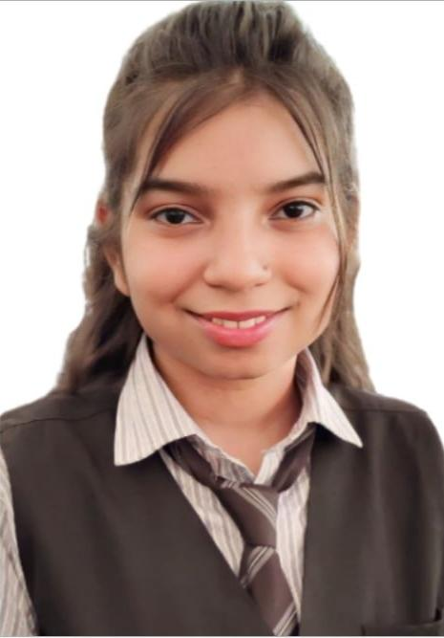

**MEENAKSHI PANDEY**

Katni

7999572118

[Meenakshipandey1312@gmail.com](mailto:Meenakshipandey@gmail.com)

**OBJECTIVE:-**

**Looking for a challenging job where I can use the knowledge and skills during my academic career and develop grow Professionally by exploring new vistas of life .**

## **EDUCATION:-**

| **COURSE/DEGREE** | **Bored/University** | **PASSING YEAR** | **CGPA/**  **PERCENTAGE** |  |
| --- | --- | --- | --- | --- |
| **B.Tech** | **Rajiv Gandhi prodyogiki vishwavidyalaya Bhopal** | **2024**  **(pursuing)** | **8.17CGPA**  **(Current sem)** |
| **XII** | **MP board** | **2020** | **89.7%** |
| **X** | **MP board** | **2018** | **94.4%** |

**SKILLS:-**

* **HTML**
* **CSS**
* **Javascript**
* **Python**
* **C++**
* **SQL**
* **Visual Studio**

**Certification:-**

* Introduction of HTML,CSS(Great learning)
* Basic of python programming(Great learning)
* Software Development Championshi**p**

**Training :-**

**Training in Web Development**

**Duration: [February 2023] - [April 2023]**

**Description:** Completed comprehensive training program

in OPTUS.

**RELEVANT COURSES:-**

* Basic of Computation
* Internet and Web Development
* Software Engineering
* Cyber Security(basics)
* DBMS
* Advanced Computer Architecture
* Computer Network
* Machine Learning

**Projects**

* **Online Calculator Web Application**
* **Description:** Developed an online calculator web application using HTML, CSS, and JavaScript. Designed the user interface for optimal user experience and implemented core calculation functionality for addition, subtraction, multiplication, and division. Ensured cross-browser compatibility and responsiveness. Received positive user feedback for its ease of use and contributed to the enhancement of problem-solving and coding skills.
* **School and College Management System**
* **Description:-**I made a website to help schools and colleges keep track of student information and attendance

I was in charge of designing and building the

system.It made things easier for teachers and

students,It saved time by tracking attendance . automatically. It helped with tasks like tracking managing courses, and keeping student records organized. I worked with a team to make sure everything worked smoothly.

I worked with a team to make sure everything worked smoothly

**Key Achievement**

* I got better at building websites and solving problems.
* Learned how to manage projects and work in a team.
* Got better at web development, like creating websites and managing data.
* Became better at solving problems and thinking critically

**Design Tools:-**

Canva,Adobe photoshop,Picsart

**Extracurricular Activities**:-

Event Manager | College Event Coordinator

March 2023-April2023

Successfully coordinated the annual college cultural festival Spectra 3.0 ,overseeing a team of 20 volunteers and managing a one Lakh budget.

Demonstrated strong problem-solving skills by addressing logistical challenges and ensuring the event ran smoothly.

Effectively communicated with team members, sponsors, and attendees, showcasing collaboration and teamwork abilities.

Showcased meticulous attention to detail in event planning and execution.

Adapted to changing requirements, displaying flexibility and a proactive approach.

Initiated and executed a successful social media campaign, boosting attendance by 40%.

Acquired technical skills, including the use of event management software and databases.

**Linguistic Ability:-**

* English
* Hindi

**Strength:-**

* Determined and Disciplined
* Team Worker & Multitasking
* Leadership and Adaptability
* Problem solving & planning and organizing tasks